1. **Sign in to AWS Console:**
   * Go to the [AWS Management Console](https://aws.amazon.com/console/).
   * Sign in with your AWS credentials.
2. **Navigate to S3 Service:**
   * In the AWS Console, search for **S3** in the search bar and select **S3** from the list.

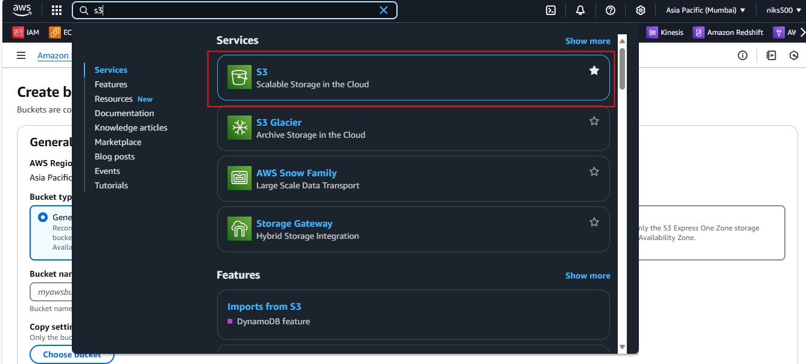

1. **Create Bucket:**
   * Click on the **Create bucket** button.

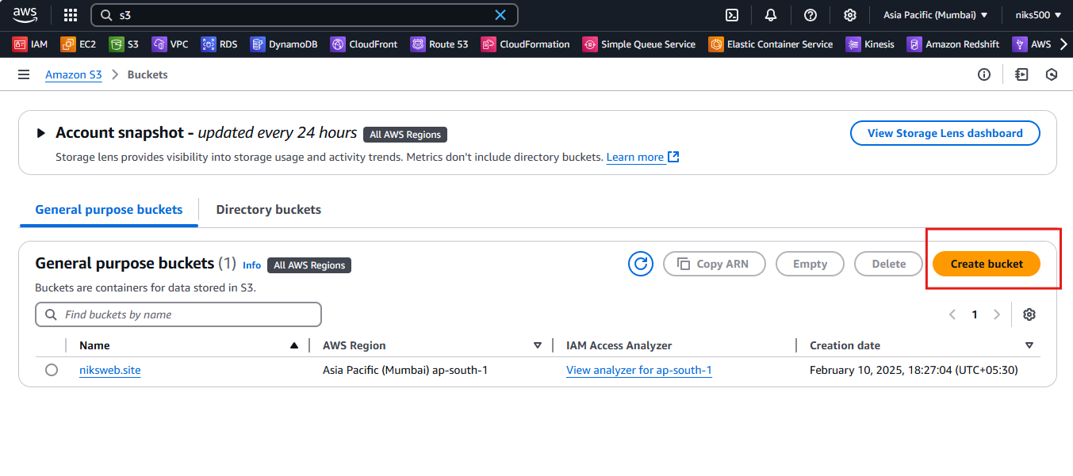

1. **Configure Bucket:**
   * **Bucket Name:** Provide a globally unique name for your bucket (e.g., my-unique-bucket-1234).
   * **Region:** Select the AWS region where you want to create the bucket (e.g., US East (N. Virginia)).

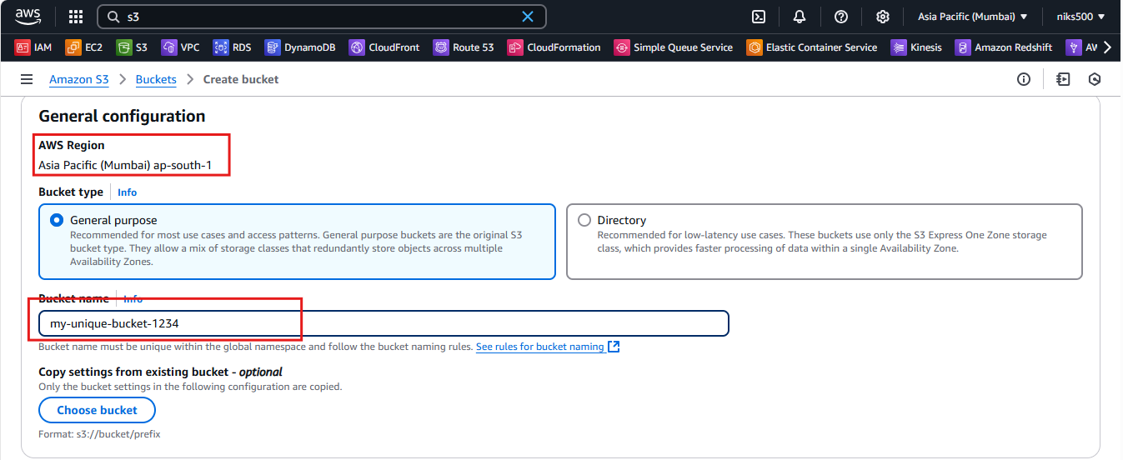

1. **Set Bucket Options:**
   * **Versioning:** Optionally, enable versioning to keep multiple versions of an object.
   * **Tags:** Optionally, you can add tags to categorize or manage your bucket.
   * **Object Locking:** Choose if you need object version locking for compliance.
2. **Set Permissions:**
   * **Block Public Access:** By default, it blocks all public access. This is recommended unless you specifically need a public bucket.
   * **Access Control List (ACL):** You can set permissions at this stage if required.
   * **Bucket Policy:** If needed, you can add bucket policies to define more specific permissions for accessing objects in the bucket.

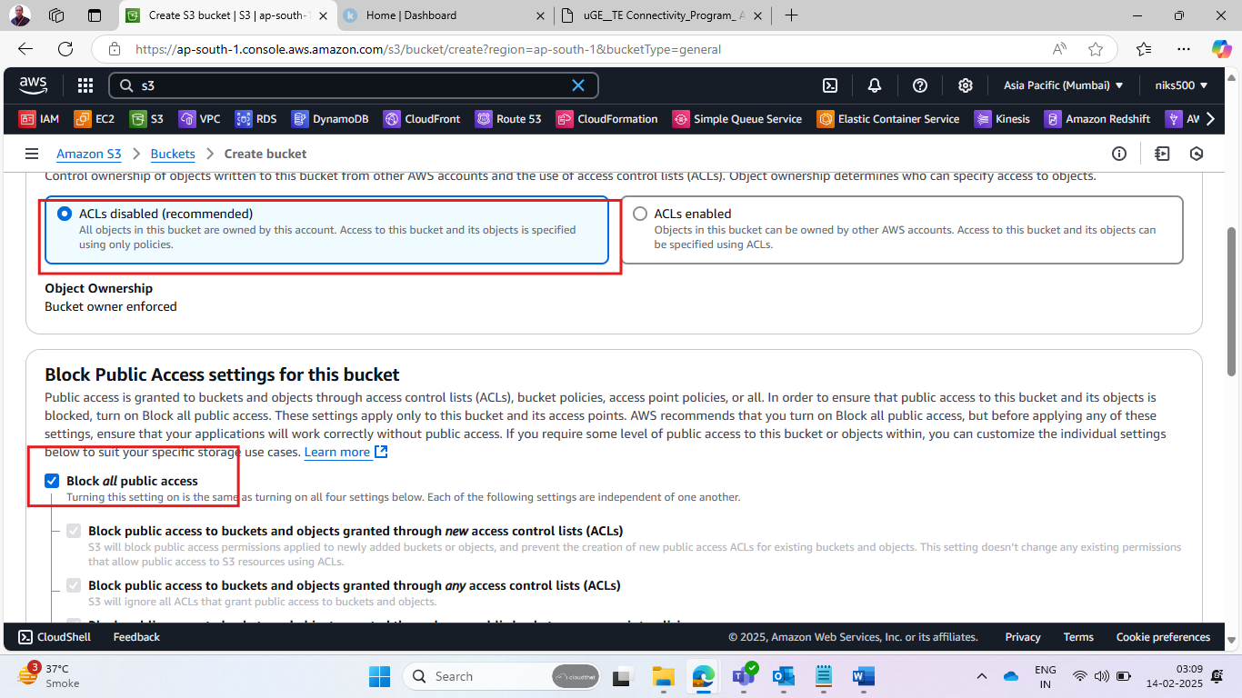

1. **Review and Create:**
   * Review your settings, and click **Create bucket**.